**Home**

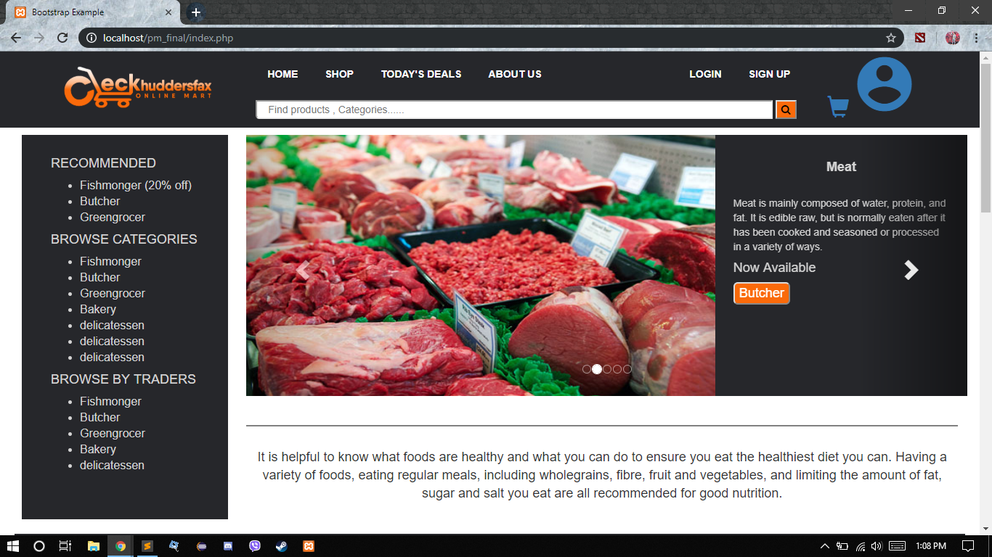

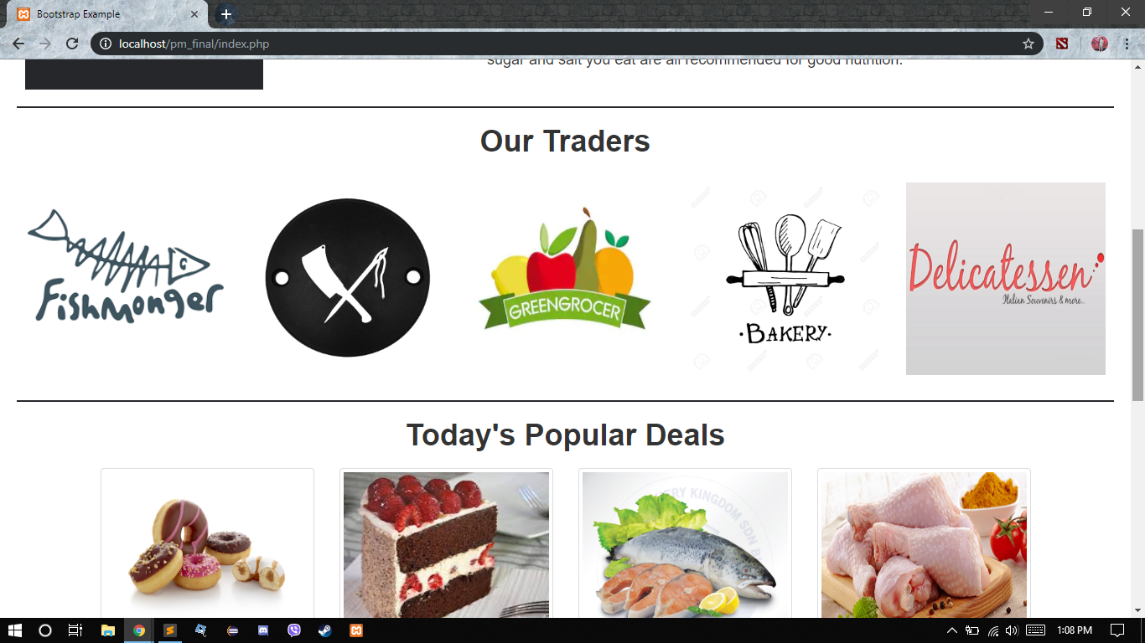

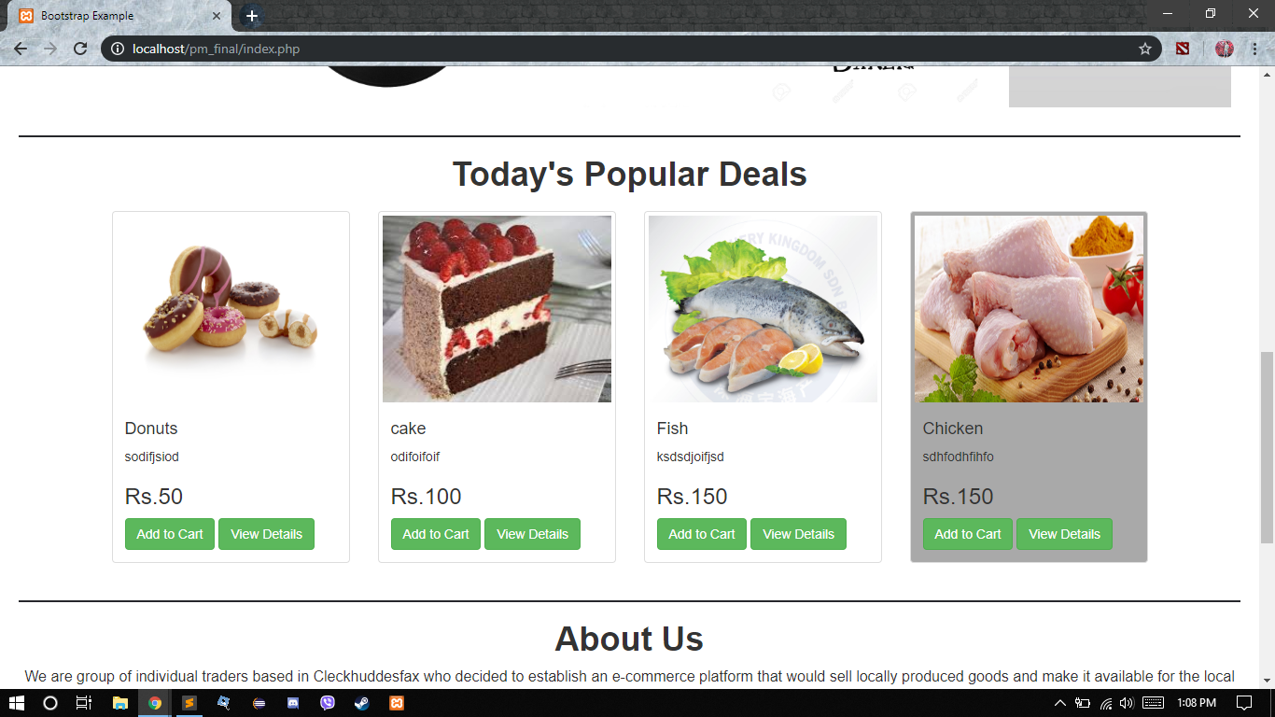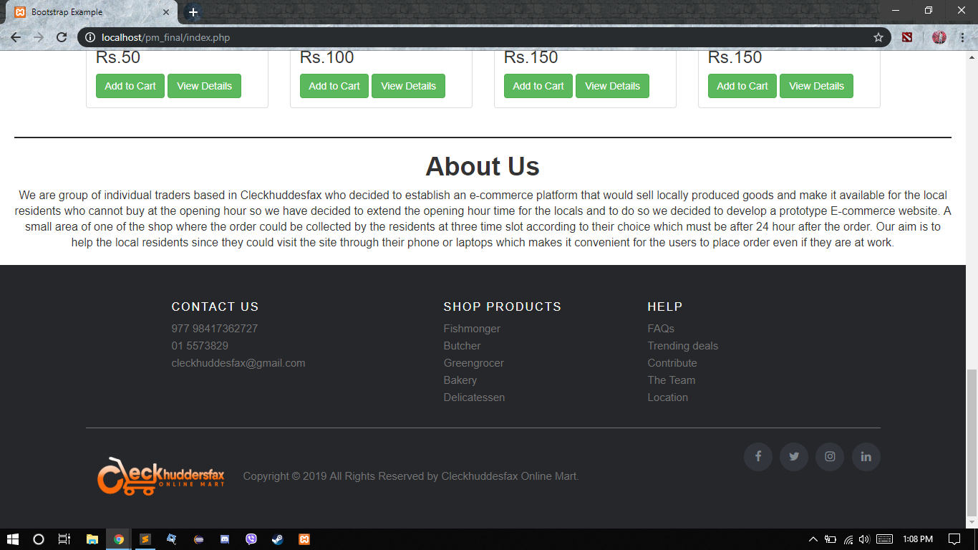

This is the home page that the user will see which has slider, browse options, today’s deal, and our traders. When you click on the browse option for like fishmonger, butcher, greengrocer, bakery, and delicatessen it will lead you to the fishmonger page and so on. If you add to cart it goes to the cart page that is right beside the profile logo.

**Shop**

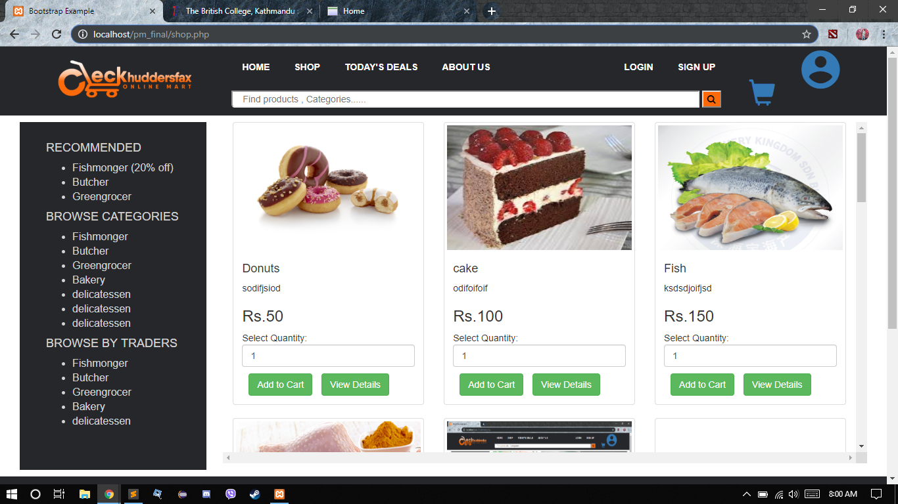

This is the shop page which has all the product items where you can select the quantity you want and add to cart accordingly. And it also allows you to browse according to the traders as well if you want some specific item from a specific trader.

**About Us**

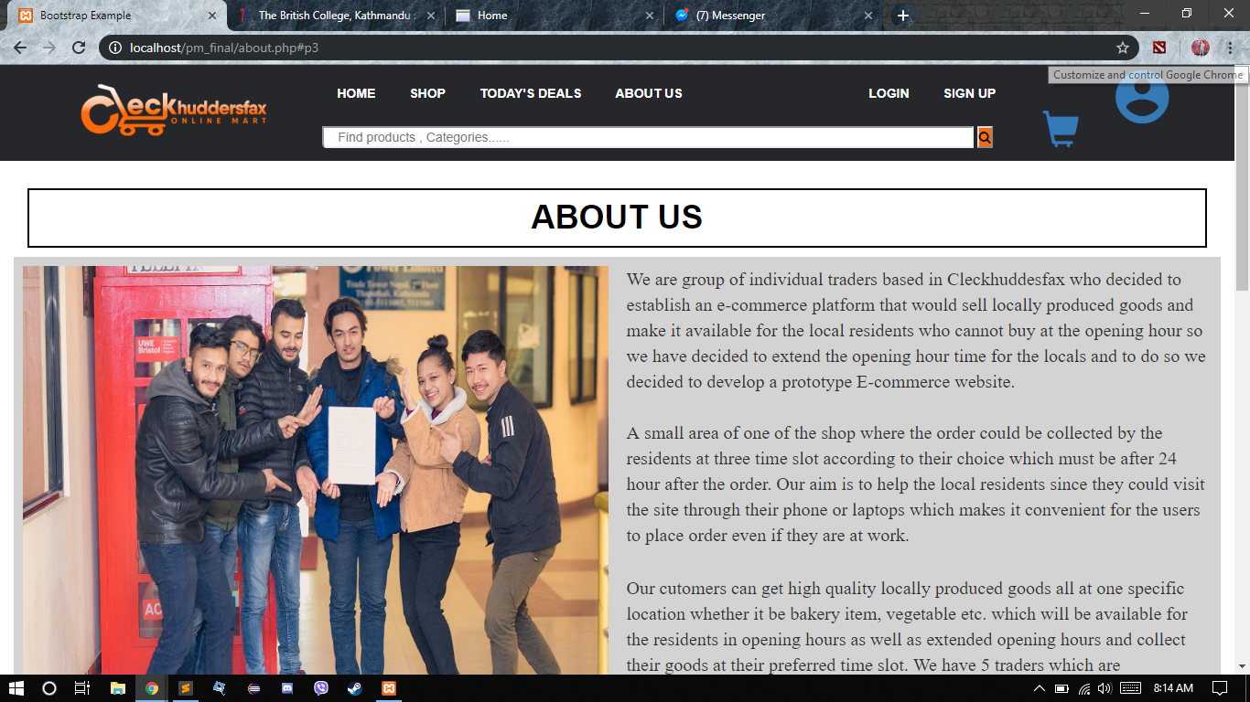



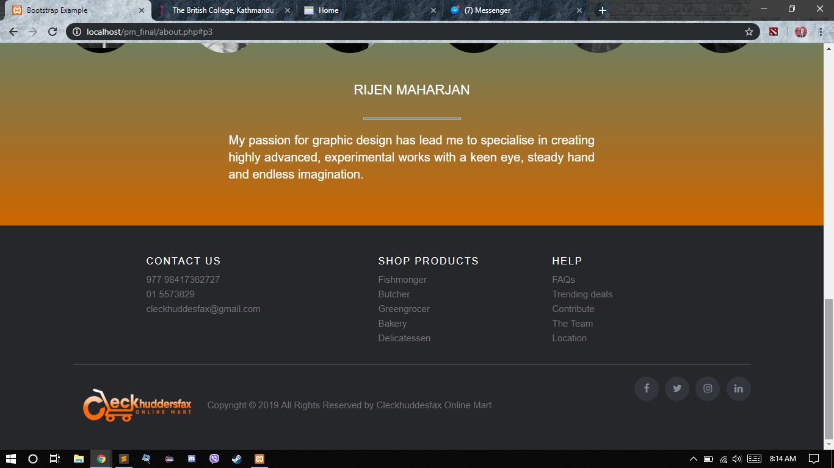

The customer can view the about page to know about the “Cleckhuddersfax Online Mart” and can get to know about each team members.

**Register**

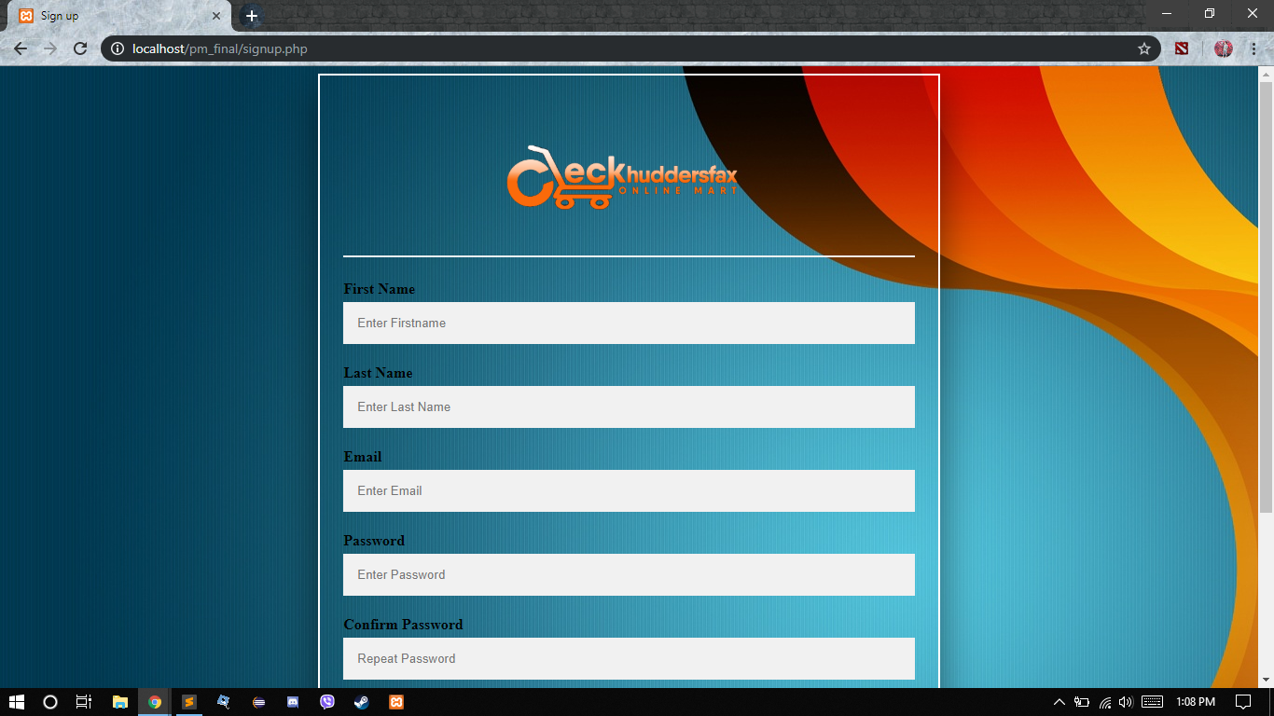

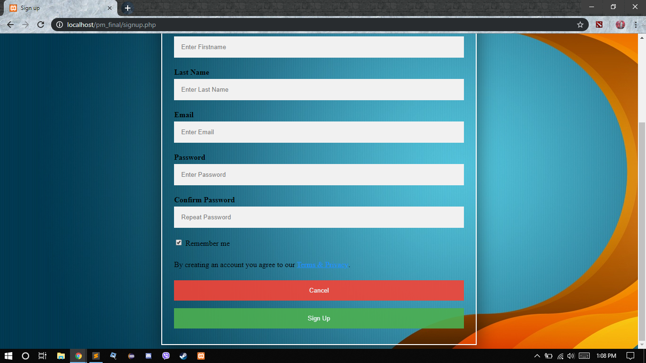

The customer can register themselves by filling up their details which include first name, last name, email, and password and confirm password and sign up which will send up and email verification to the user.

**Login**

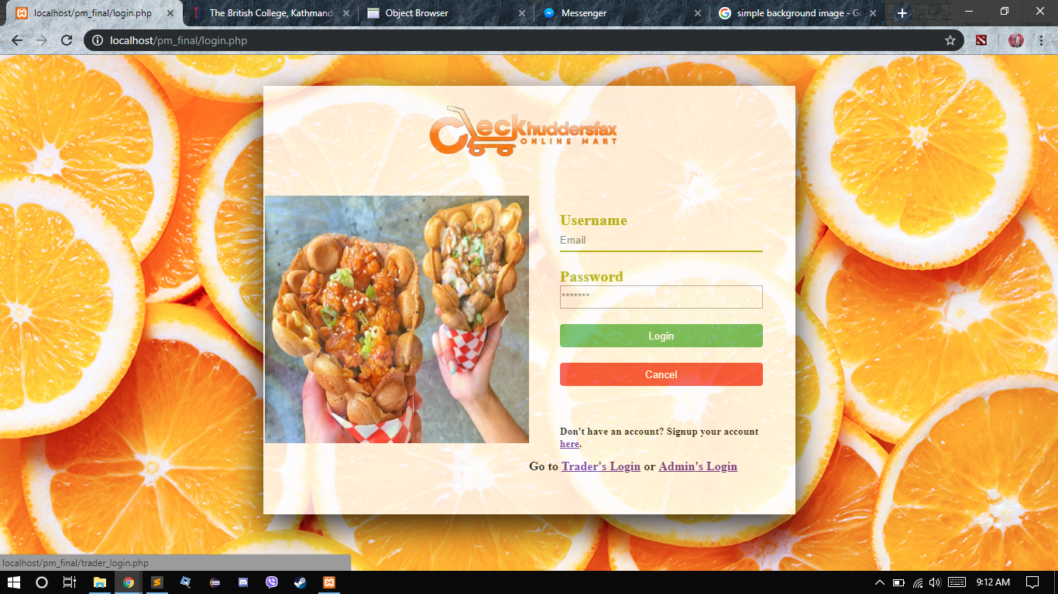

Customer can login with their valid credentials by entering their email and password.

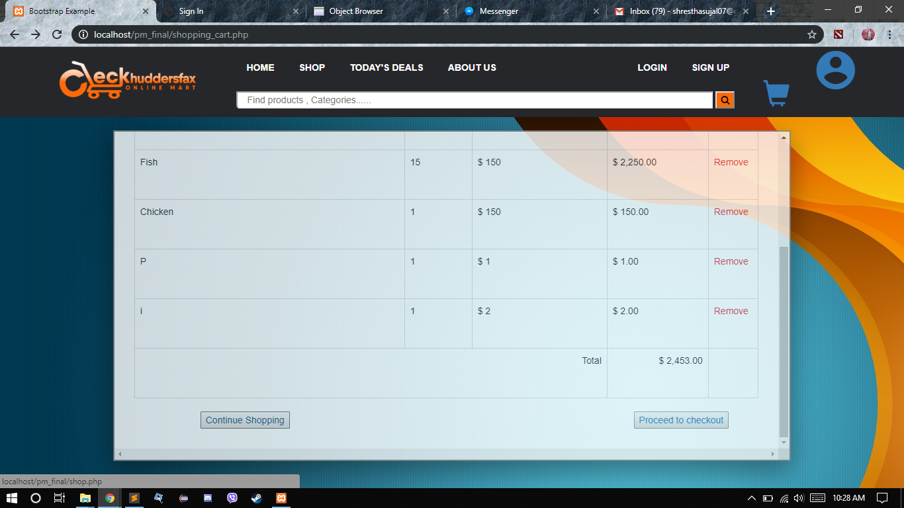

When the customer adds item it gets into the shopping cart where you can see the name, quantity, and price and remove item if you wish to remove items and then you can proceed to checkout.